Course: Web Application Development
Lab Instructor: Dr. Le Duy Tan
Email: ldtan@hcmiu.edu.vn

Lab 3 - Introduction to Servlet Programming (25/3/2022)

Content:
- Introduction to Java Servlet Technology
- How to create a servlet and run on NetBeans IDE
- Practices and Exercises

Duration: 3 hours

Part 1: Introduction to Servlet and Servlet Life Cycle.
- Recall: What is Servlet?
  - A servlet is a Java programming language class that is used to extend the capabilities of servers that host applications access via a request-response programming model.
  - Although servlets can respond to any type of request, they are commonly used to extend the applications hosted by web servers. For such applications, Java Servlet technology defines HTTP-specific servlet classes.
- How Java support Servlet Programming
  - The javax.servlet and javax.servlet.http packages provide interfaces and classes for writing servlets. All servlets must implement the Servlet interface, which defines servlet life-cycle methods.
  - The HttpServlet class provides methods, such as doGet and doPost, for handling HTTP-specific services.
  - When implementing a generic service, you can use or extend the GenericServlet class provided with the Java Servlet API.
- Tomcat Servlet/JSP container
  - Tomcat can act as a stand-alone Web server and also as a servlet/JSP engine for other Web servers. When you download the Tomcat server, you really get a number of packages. Catalina and Jasper are the names of the servlet and JSP containers.
  - Tomcat by itself is a web server. This means that you can use Tomcat to service HTTP requests for servlets, as well as static files (HTML, image files, and so on). In practice, however, since it is faster for non-servlet, non-JSP requests, Tomcat normally is used as a module with another more robust web server, such as Apache web server or Microsoft Internet Information Server (IIS).
  - Tomcat is not a J2EE application server. However, as J2EE app servers must themselves contain a servlet container to support the servlet/JSP APIs, J2EE app servers can embed Tomcat into their code to provide support for the Servlet and JSP APIs. One example of just such an application server is the popular open source JBoss J2EE app server (http://www.jboss.org/).
- Servlet Life Cycle
  - The javax.servlet.Servlet interface defines the methods that all servlets must implement and, among others, three methods that are known as life-cycle methods:
public void init(ServletConfig config) throws ServletException
public void service(ServletRequest req, ServletResponse res) throws ServletException, IOException
public void destroy()
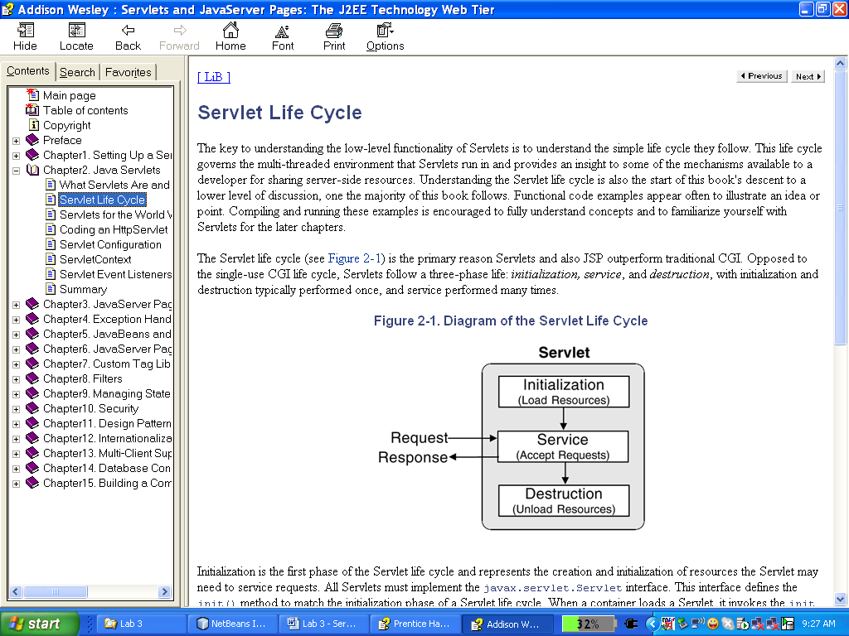
  - These life-cycle methods are each called at separate times during the life span of a servlet, from the initial creation to the moment it’s removed from service and destroyed. These methods are called in the following order:
1. When the servlet is constructed, it is initialized with the init() method.

2. Any requests from clients are handled initially by the service() method before delegating to the doXxx() methods in the case of an HttpServlet. The service() method is responsible for processing the request and returning the response.

3. When the servlet needs to be removed from service, it’s destroyed with the destroy() method, then garbage collected and finalized. When the container decides to take a servlet out of service, it first ensures that any service() method calls have been completed.

  - The init method is called by the servlet container after the servlet class has been instantiated. The servlet container calls this method exactly once to indicate to the servlet that the servlet is being placed into service. The init method is important also because the servlet container passes a ServletConfig object, which contains the configuration values stated in the web.xml file for this application.
  - The service method is called by the servlet container after the servlet's init method to allow the servlet to respond to a request. The servlet container passes a ServletRequest object and the ServletResponse object. The ServletRequest object contains the client's request and the ServletResponse contains the servlet's response.
  - The servlet container calls the destroy method before removing a servlet instance from service. This normally happens when the servlet container is shut down or the servlet container needs some free memory.
(More information: refer from textbook: Core Servlets and Java Server Pages)
Part 2: How to create a Servlet on NetBeans IDE.
- Default servlet creation
After create a website (lab 1) on NetBeans IDE, right_click to the name of website -> New -> Servlet…
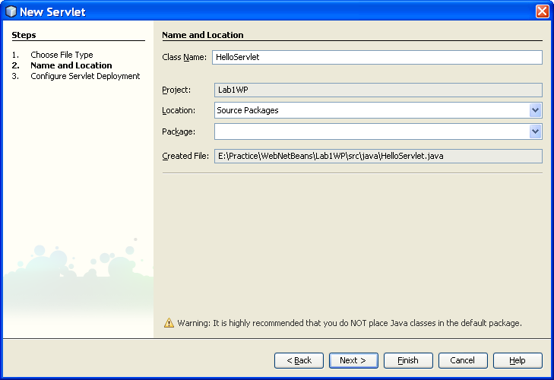
Type a name and click next, then click Finish button, the source codes generate automatically in the file HelloServlet.java.

This is source code:
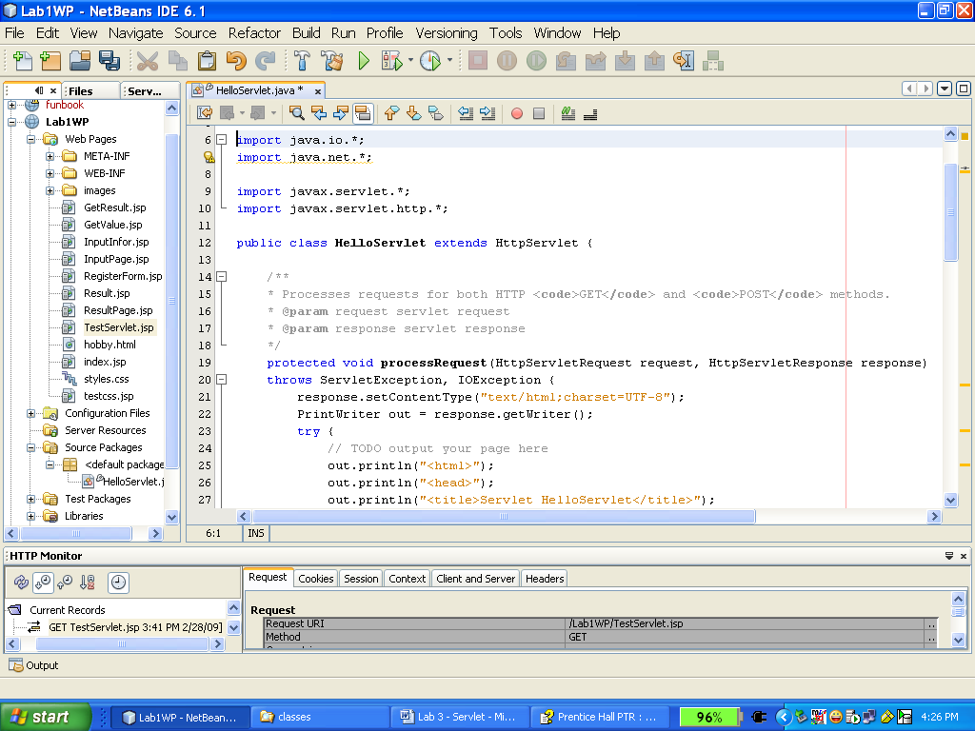
After building and running on the web server, this is the result page.
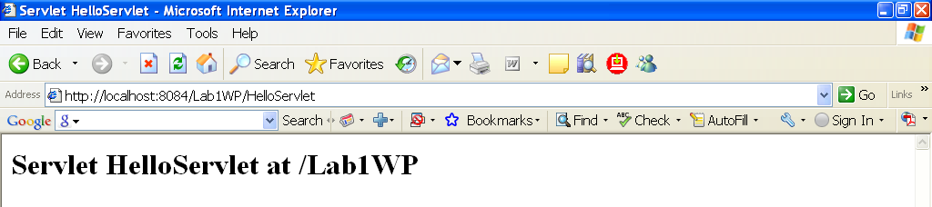
- Custom serlvet creation
During application development, we might need to create more servlet. The steps to create new servlet in project are illustrated as figures:
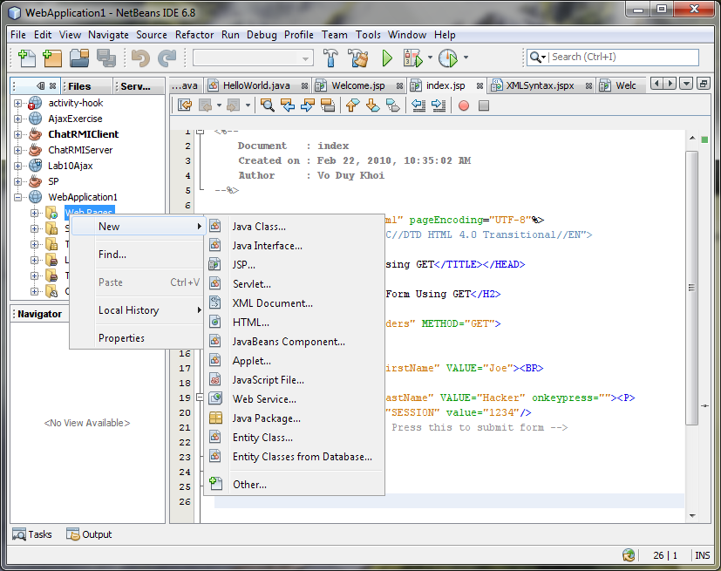
Choose menu “Serlvet” to create new servlet. You should not choose normal “Java Class” then write class as servlet. If you do so, you have to configure to activate servlet manually.
- How to run a servlet
A servlet can be called by name of class without extension. For example, if your create a servlet class named “HelloWorld.class” and run it under context /Lab3 then your URL to run the servlet will be “/Lab3/HelloWorld” and one message will display as follows:
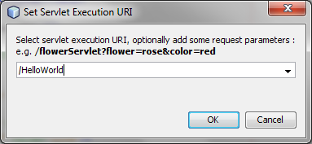
Part 3: Practices and Exercises.
Exercise1: design a form (ThreeParams.JSP) as below:
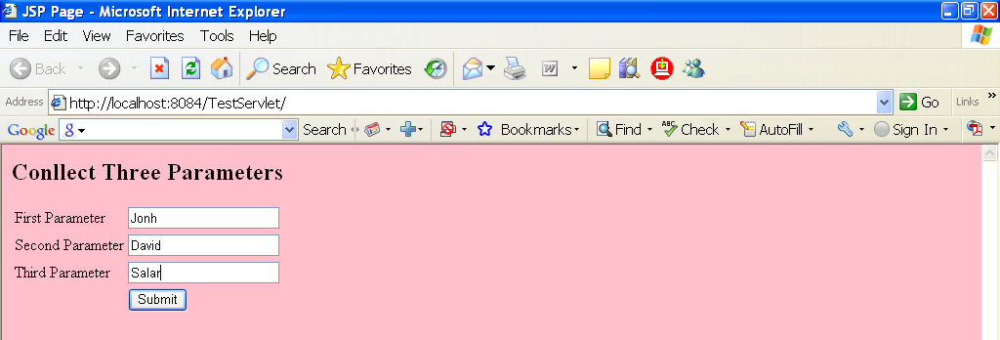
After input three values in the textbox -> click Submit button, it call result page GetThreeParam.class (this file is built from GetThreeParam.java)
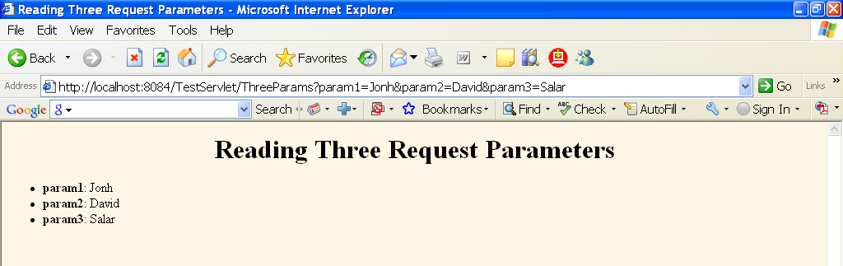
Exercise 2: Design form Personal Information (PersonalInfor.jsp)
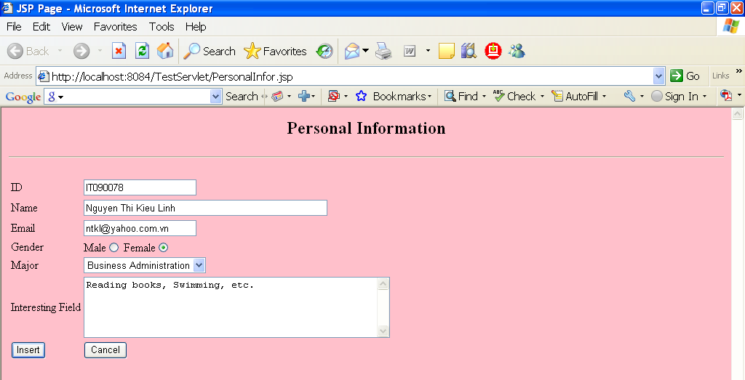
The result from GetInfor.java
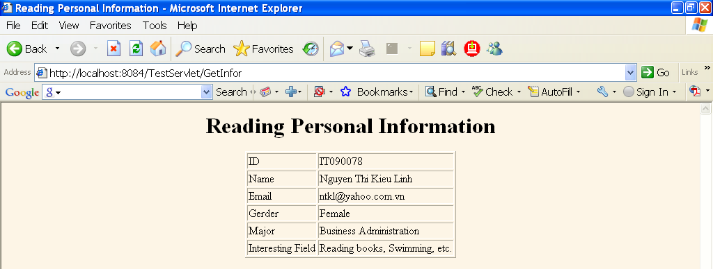
Exercise 3: Design a register form, use Servlet to get all information when user click the Submit button and put into a new page.
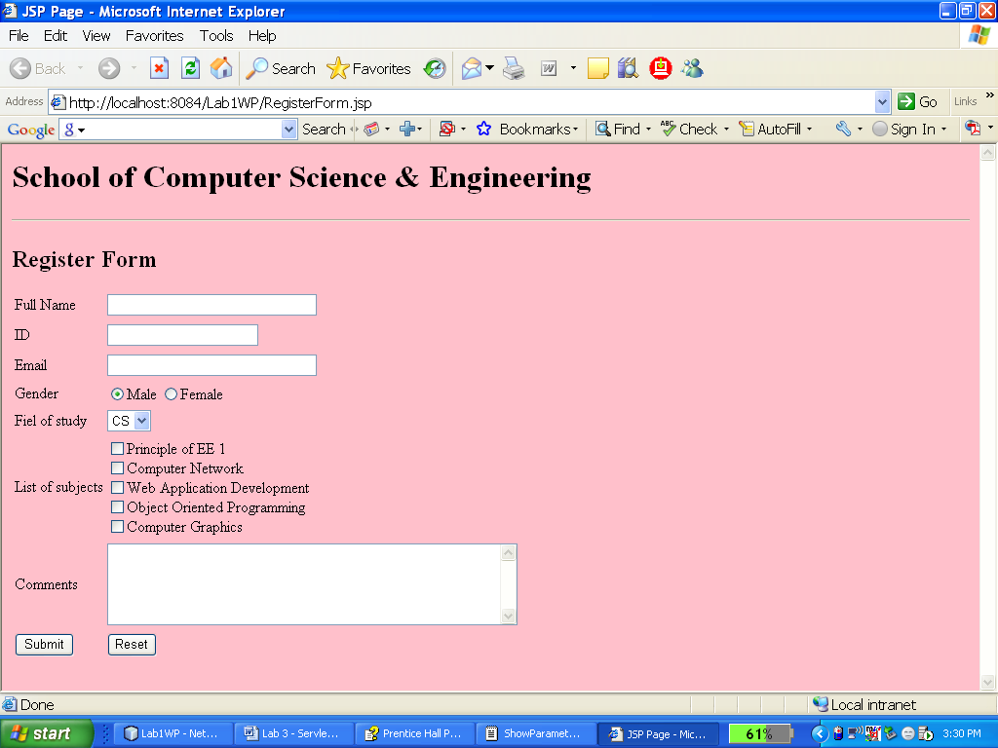
The result show parameter Servlet (RegisterCourse.java)
Exercise 4 (bonus): You are required to modify the servlet in Exercise 3. When a user clicks on Submit button, all information will be sent to your email. You can use any technology, service or third party library to support the development of email function .

